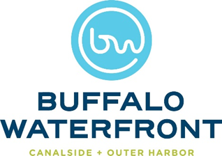

2022 Buffalo Waterfront Food Vendor Application
Vendor/Food Truck: ___________________________________________
Owner: _____________________________________________________

Contact Information
Address: ____________________________________________________
Email: ______________________________________________________
Cellphone: ___________________________________________________
Website: ____________________________________________________
Facebook: ___________________________________________________
Twitter: _____________________________________________________

Business Information
Size (length) of truck: __________________________________________
Time in business: _____________________________________________
Other associated businesses (i.e. restaurant, franchise, etc.) ___________ ___________________________________________________________
Description of menu offerings: ___________________________________ ____________________________________________________________
Additional info: _______________________________________________
Is your business a WBE or MBE (Women Owned/ Minority Owned Business): ___________________________________________________

Please include/attach a photo of your cart/truck/tent and submit to swilson@buffalowaterfront.com

